App Name: TransitDB Vancouver

App Developer: Carson Lam

Play Store Rating: 4.6 out of 708 reviews

Version: 2.1.3.0

Number of Downloads: 50,000 - 100,000

Last updated: January 3, 2017

Usability:

The main sky train related features in TransitDB were easy to find and easy to use. There are additional labels on many of the sky train stations to indicate if it has transfer options to different routes. Every text field you wish to enter offers a help tip to indicate what you are supposed to type in that area. The app gives the next 6 trains from the current time but they are based on schedule and not real time updated.

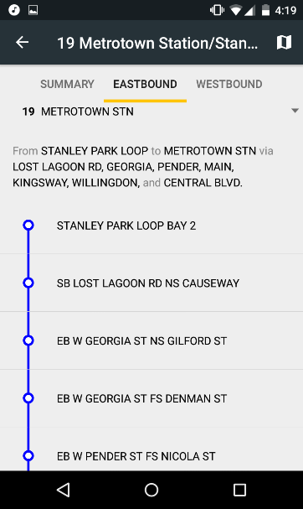

First and last departures of the day are also displayed for each station. At the bottom of each station bus connections to other stations are displayed as buttons for the names of each bus. If you click on them they expand to a new activity and show similar information to the sky trains such as the next 6 buses arriving and the frequency of buses on particular days of the week.

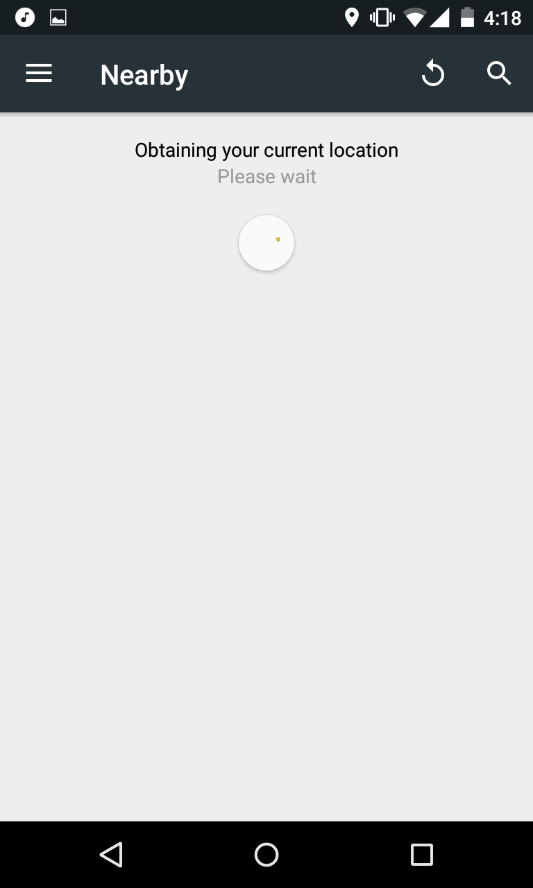

The app visibly shows the fare zone of each station so you can determine how much money to load or what ticket to buy before departing on your trip. If this app included a trip planner it would have been helpful to display these total fares after a starting point and destination were selected. For use of strollers and wheelchairs the app shows if each station has features including wheelchair access, elevators, Wi-Fi, bike accessibility and more.

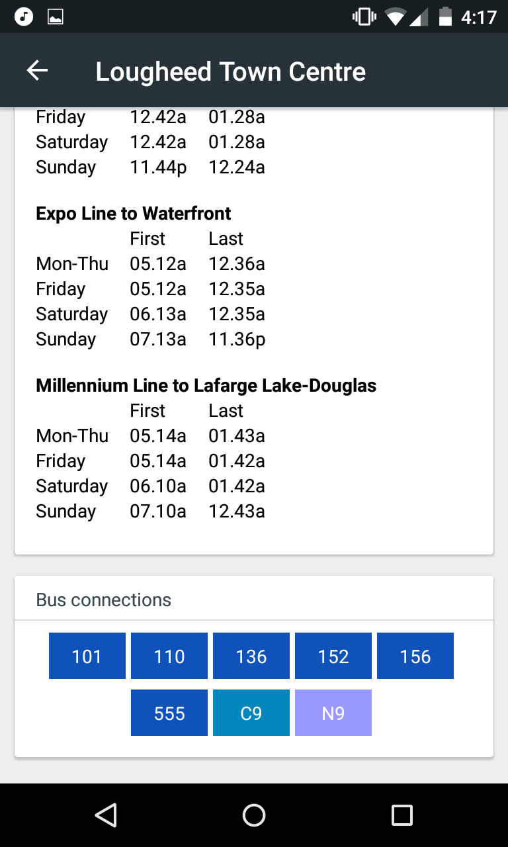

Aesthetics:

The app does not include a live map of all stations but is instead a text based design what it lacks in visually pleasing aesthetics it gains in ease of use and simplicity. The colour scheme is very bland with very few colours only used as backgrounds on title labels and sky train diagrams.

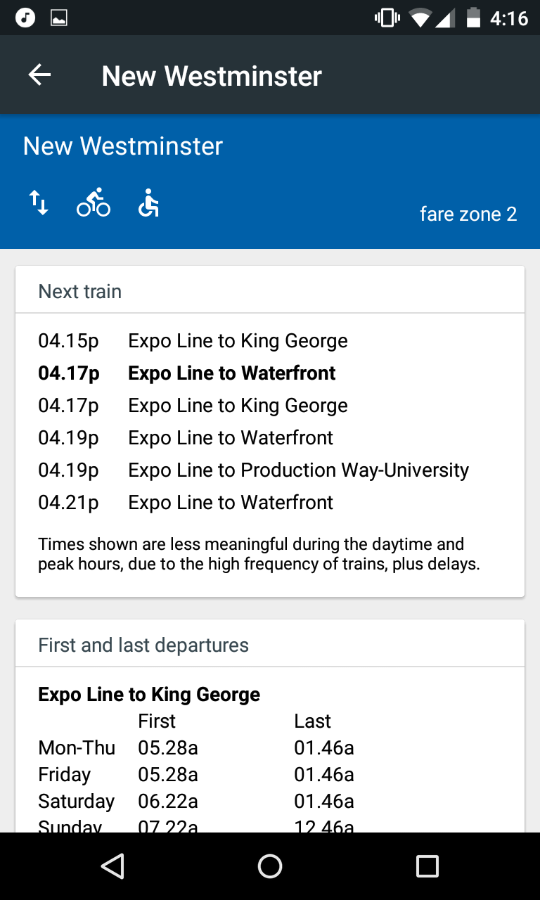

While a black/grey/white colour palette isn’t for everyone I quite enjoyed the easy on the eyes feel of the app. I found the font size to be readable yet spacious and flowed well with the design of the app.

Responsiveness:

Since TransitDB is text based and can be used offline the response time of all its options is very speedy and any lack of response time I condemn to the age and power of my phone not the app itself. The search function is near instantaneous at collecting large pools of data from its storage. The app has never crashed in my short time using it and I have seen in the changelogs that reported crashes caused by bugs are fixed within a very short period.

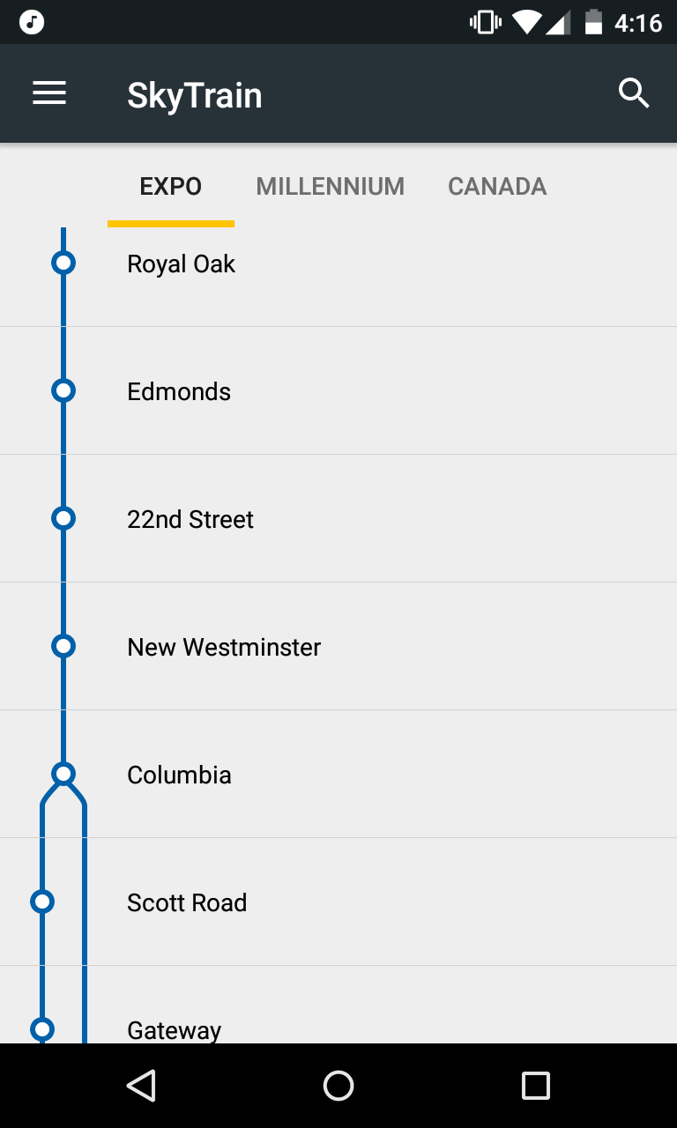

Additional Features:

The app also displays bus routes, seabus and west coast express. It also features a very useful compass card loading system which can update u-pass and check current balance. The app also presents information about taxi fares and phone numbers to contact a designated taxi. My app has an additional section to show transit fares and which zones.

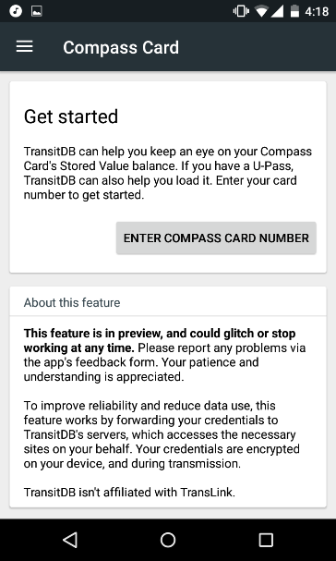

Some features which are not included in the app that I would like to see are a trip planner as you have to know exactly which route you are taking to use this app effectively and a live map with use of the location setting to determine where you are and where you need to get.

Support:

App was most recently January 3rd 2017, fairly recently and was one of the very first apps to update the new evergreen extension almost immediately after its release on December 2nd 2016 and It also updated the bus routes shortly after December 19th 2016 when they went into effect.

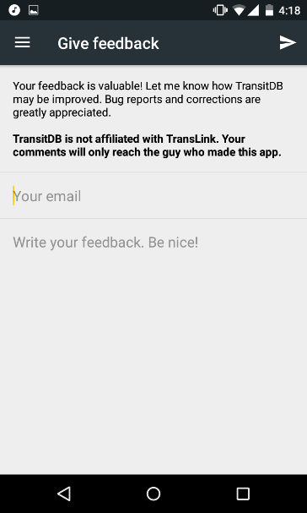

TransitDB includes a changelog which goes almost a full 2 years back from current date. If you find bugs or experience consistent crashes, there is a useful “give feedback” feature to let them know of your inconvenience with just an email and feedback text fields.

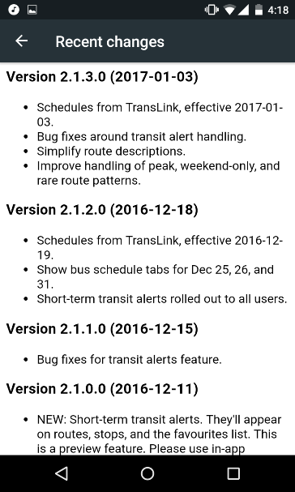

Another criticism I have of TransitDB is that it does not include a map of all the sky train stations and which line they are on.

Conclusion/Evaluation table:

Overall, I found the app to be extremely effective at a niche usage of finding timings of sky trains and bus arrival times for short term planning. Personally I enjoy this app for its simplistic features and fast run times, however I can see that for long trips or navigation it can be far from ideal. I can also see that the many improvements I suggested would come at a cost to the apps responsiveness and support.

|  |  |  |
| --- | --- | --- |
| Criteria | Weight | Score |
| Usability: | 35 | 30 |
| Aesthetics: | 20 | 15 |
| Responsiveness: | 20 | 20 |
| Additional Features: | 10 | 6 |
| Support: | 15 | 15 |
| Total: | 100 | 86 |

Ideal app:

-Colour Themes

-Real Time Sky train times (have to be official)

-uses comic sans

-Fast Load times

-Trip planner or start/final destination

-Additionally includes some bus times from stations